Team: The Green Machine

**Sustainability Pledge Website**

**Final Report**

**Technologies Used:**

Angular CLI

Firebase CLI

VS Code

BootStrap

Jasmine & Karma

JUnit and Selenium

**Features Implemented:**

· Save users’ information to database

· Save users’ input for Get Involved page into database

· User verification via email

· Revamp the UI

· Bootstrap Navigation Bar

· Added information tabs: News, Past Events, Profile

· Implemented admin privileges to users

· Admin tab is properly routed for users that are admins

· Pledge behavior (show one at a time) and answer options

**Features to be done:**

· Implement admin view and query database information (users’ and Get involved info)

**Known Issues:**

· Because the way the system saves the users at login to the database, every time you login the admin privileges get reset to false.

· At time of deployment the pledges are aligned to the very left edge of the screen

· Currently, pledge questions do not have unique IDs

**Live Demo:**

[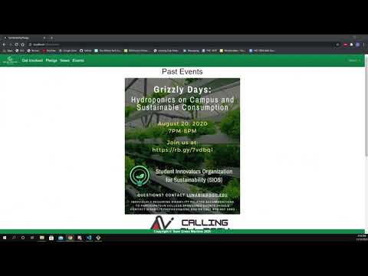](https://www.youtube.com/embed/a9Ixflzd_Ko?feature=oembed)

**Project Flyer**

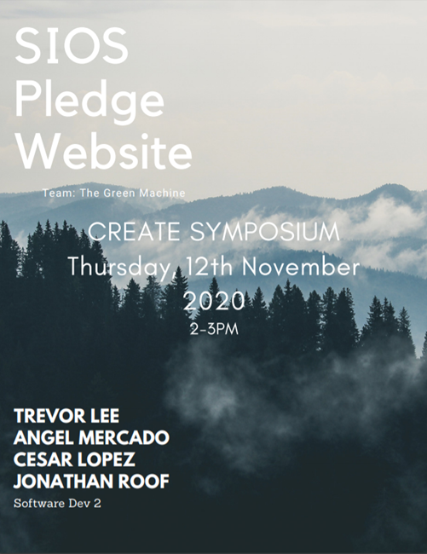

**The Green Machine Members:**

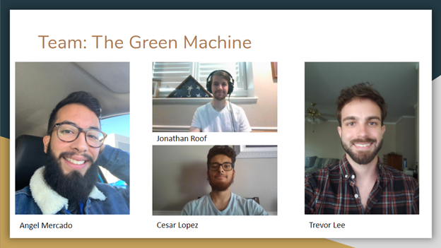

**Trevor Lee:** Testing Lead, Team Manager.

o 26, Senior: Software Developer Major

**Angel Mercado:** Data Modeler, Documentation.

o 24, Senior: Software Developer Major

**Cesar Lopez:** Lead Programmer, Documentation.

o 22, Senior: Software Developer Major

**Jonathan Roof:** UI/UX Design, Client Liaison.

o 22, Senior: Software Developer Major

**Client:**

**Le Quang Greatzel Unabia**

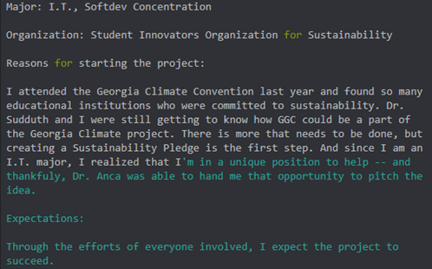

**Survey:**

* You can find our full survey responses in the folder called Fall 2020 Documents and the file is called survey results but below is a screenshot of some of our survey responses:

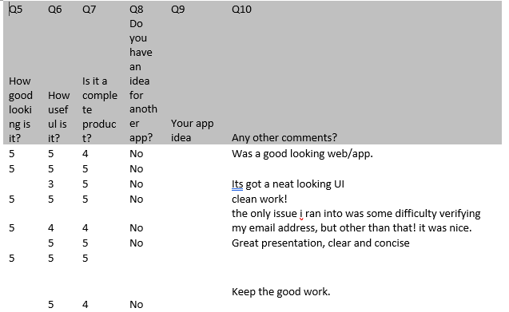

**where to find installation, developer, and user documentation:**

To access the files go to our github repository link provided below:

<https://github.com/GGC-SD/SustainabilityWebsite>

Here the client and developer will have access to all files.

The current version of the website is currently deployed link below:

<https://sios-sustainability-pledge.web.app/home>

**For Developer installation:**

Angular 9 or newer would have to installed in their computer

The most recent version of node.js would have to installed

For IDE: the recommended IDE would be Visual Studio Code

After completion of the installation:

You will clone the project on to your computer

To do this you will have to go to the repository and click the code button and click the clipboard icon to copy the repo

Then you have to go to gitbash and in gitbash you go to the location you want the files to all be. Wait while everything processes.

After that open project in your preferred IDE and run the project.

**For Use Client:**

Tabs:

Nav bar:

The nav bar includes get involved, pledge, news, events, and a menu dropdown button which includes Profile, Login/logout, about, FAQ

Home:

In the home tab you will find a flyer to the most recent event and there will be a pledge button to redirect you to the signup/login.

Login/signup:

Signup:

You will enter your email and password and click the signup button and complete the form, and verify email

Login

Enter login credentials and click login button

Pledge:

You will be able to complete pledge questionnaire once you have logged in

Get Involved:

In the get involved tab you will see a form and you will be able to enter credentials to get information to attend events.

News:

In the news tab you will have access to links that are about the sustainability committee and access to the Globe GGC

Events:

In the events tabs you will see the most recent events

Profile:

Will need username and email

About:

Just has info on the developers

FAQ:

Just includes frequently asked questions

**For installation developer:**

The developer will have installation instructions in README.md

**Software License**

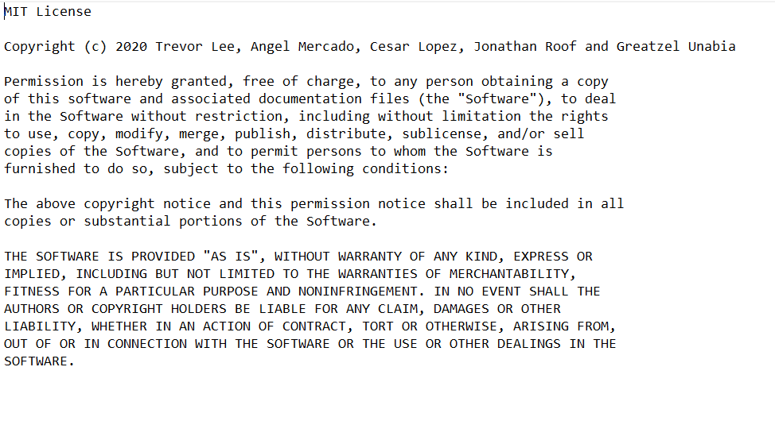

**Intellectual Property Terms**

